The Benefits Handcrafted Soaps
- Handcrafted soaps do not contain all the harsh ingredients that can cause allergic reaction like commercially made soaps.

- Pure Natural ingredients! Orchid Valley uses only pure natural Olive Oil as a base for its soaps. NO animal products are used. All of our soaps are scented with natural fruits, herbs, spices, and high quality essential and fragrance oils.

- The natural glycerin that occurs as a result of the natural soapmaking process is not removed from our soaps. Glycerin is a fabulous cleanser and moisturizer in one. Our soaps will leave your skin feeling silky and smooth.

Orchid Valley
1942 Route 313
Perkasie, PA 18944
215-258-0544

Orchid Valley Essentials is a division of A Touch of Health Massage Therapy

This brochure was provided to you by:
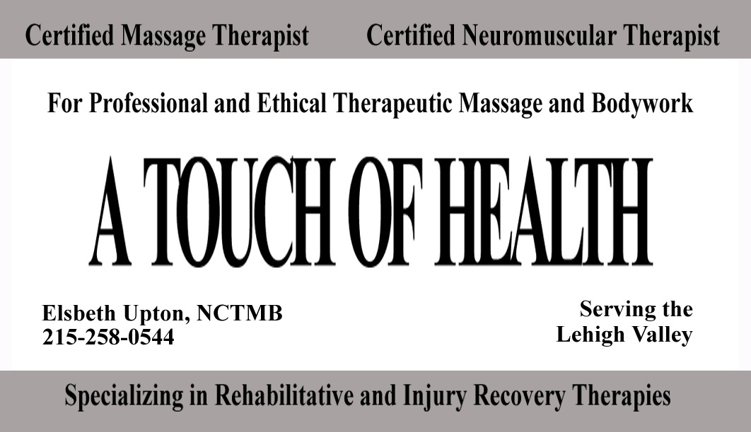

Orchid
Valley Essentials
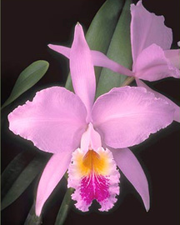
Handcrafted Soaps
to nourish the body and soul

Why Use Handcrafted Soaps?…

There are very few commercially made soaps that are really natural. Have you ever noticed when you buy commercially made soap what the label actually says? Take a moment and notice the label, does it even say soap? Most are labeled “Beauty Bar”, Bath Bar,”, or “Cleansing Bar”, they are not actually even soap. The FDA will not allow them to label their products soap, because in order to be soap, saponification must occur. Saponification is the process of combining a fat and an alkali to form a neutral compound. So what are they really if they do not under go the process of saponification? They are simply detergent bars.

Handcrafted soaps are wonderful for your skin because they still contain the natural glycerin which occurs as a result of the soapmaking process. Most commercial soaps have their glycerin extracted and sold to other industries. That is why your skin feels dry and itchy after you use them. The glycerin in handcrafted soap leaves your skin feeling silky soft. Handcrafted soaps do not contain all the harsh ingredients that can cause allergic reaction like commercially made soaps.

All Orchid Valley Essentials’ soaps are made in small batches, so there may be some variation from batch to batch, but they all have the same base ingredient, pure olive oil

Glycerin
Glycerin is naturally produced during the handcrafted soap process. In fact pound for pound, glycerin costs more than soap, which is why some soap companies remove the glycerin from their soap and sell it to the manufacturers of things like tooth paste and lotion. Orchid Valley Essentials does NOT remove the glycerin from their soaps. They all contain the naturally occurring glycerin which is a wonderful natural moisturizer.
Cold Process Soap
Orchid Valley Essentials’ soaps are all made by a soapmaking technique called Cold Process. Cold Process is NOT the melt and pour bases that you buy from craft stores. Cold Process soaps are made from Lye and natural fats that are saponified. Cold Process means that the saponification occurs at relatively low temperatures. The heat used in the process is a result of the chemical reaction between the lye and the liquid used in the process.

Is there Lye in Handcrafted Soap?
Lye IS used in the soapmaking process, however there is a chemical reaction that occurs when the lye molecules come in contact with the fat molecules. This reaction is a process called saponification, which specifically is to hydrolize the fat with an alkali (the lye) to form soap and glycerol. The resulting change to the two molecules is a neutral compound which is a mild effective bar of handcrafted soap.

